**C2 Eventing On The Flat Checklist 2023**

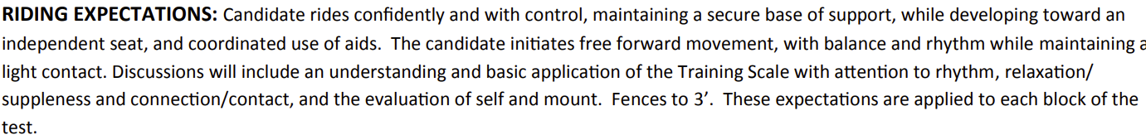Checklist is divided into On the Flat and Over Fences sections. A few boxes may be repeated on both pages if candidate is taking both sections of the test at the same time. Instructor should only sign when the candidate can consistently perform the “Riding Expectations” while performing the skills in each box.

|  |  |
| --- | --- |
| Topic | Sign and Date |
| • Discuss the meaning of the Riding Expectations.  (Including definitions of “base of support,” “independent seat,” “free forward movement,” etc.) |  |
| • Demonstrate warm-up for dressage.  • Discuss candidate’s warm-up for rider and mount, using terms from and showing an understanding of the Training Scale. |  |
| • Discuss differences in warm-up for 3 different activities of candidate’s choice. |  |
| • Work mount at walk, trot, and canter, changing directions at least twice in each gait, using coordinated aids, maintaining even rhythm, balance, energy, and smooth transitions. |  |
| • Demonstrate 15 and 20-meter circles, figure eights, serpentines and work on the center or quarter lines to develop suppleness and straightness. |  |
| • Halt squarely on centerline and stand quietly for 5 seconds.  • Demonstrate a free walk on a long rein, returning to a walk on contact.  • Demonstrate a step back of 2-3 steps.  • Discuss aids for and then demonstrate leg yield at walk. |  |
| • Ride mount without stirrups at all gaits |  |
| • Ride the current USEF Novice Test A. |  |
| • Discuss performance, including the rider’s position, and whether mount was moving forward in balance and rhythm |  |
| • Ride safely with confidence and control in a group, on a suitable mount, at the walk, trot and canter over varied terrain. |  |
| • Discuss safety measures when riding over varied footing, (e.g., water, mud, rocks, ice, bog, hard ground, sand, pavement). |  |
| • Discuss performance with Examiner.  • Rider shows firm basic balanced position while riding with control. |  |

**C2 Eventing Over Fences Checklist 2023**

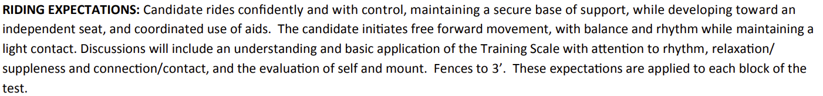Checklist is divided into On the Flat and Over Fences sections. A few boxes may be repeated on both pages if candidate is taking both sections of the test at the same time. Instructor should only sign when the candidate can consistently perform the “Riding Expectations” while performing the skills in each box.

|  |  |
| --- | --- |
| Topic | Sign and Date |
| • Demonstrate warm-up for Jumping.  • Discuss candidate’s warm-up for rider and mount. |  |
| • Discuss warm-up schedule for three different activities of candidate’s choice. |  |
| • Ride without stirrups at all gaits. |  |
| • Ride over a gymnastic grid, of trot poles to 3 fences, finishing with an ascending oxer set at but not exceeding 3’. Grid and trot poles to be set at appropriate distances for mount’s stride. |  |
| • Develop a plan of how to ride a stadium course in an enclosed area. Course to consist of 7-9 jumps with one double combination. The majority of fences set at, but not exceeding, 3’.  • Ride course according to plan. |  |
| • Discuss performance, including the quality of canter rhythm and tempo maintained throughout the course and ways ride could be improved. |  |
| • Rider should demonstrate secure basic balanced position over fences, showing control, rhythm and proper use of aids. |  |
| • Ride safely with confidence and control in a group, on a suitable mount, at the walk, trot, and canter over varied terrain, through shallow water, banks, hills, and small ditches as occur in natural terrain, as local conditions allow. |  |
| • Discuss safety measures when riding over varied footing, i.e., water, mud, rocks, ice, bog, hard ground, sand, and pavement. |  |
| • Ride over 5-7 cross-country obstacles, at appropriate speed (350-375 mpm) connecting fences as a course. The majority of fences set at, 2’6”-3’, but not exceeding, 3’. |  |
| • Discuss performance to include adjustments to pace and balance, and ways ride could be improved. |  |